Computer Science Project

(083)

TOPIC: ATTENDANCE MANAGEMENT SYSTEM



**Submitted by:  
TAVISH GUPTA**

**Roll No: 11607227**

Table of Contents:

* CERTIFICATE
* ACKNOWLEDGEMENT
* WORKING DESCRIPTIONS OF PROJECT
* FLOWCHART
* FILES GENERATED
* CODING AND OUTPUTS
* FUTURE SCOPE
* BIBLIOGRAPHY

Certificate

This is to certify that TAVISH GUPTA. roll no *11607227* of class 12A of Hillwoods School has successfully completed his Computer Science Project on the topic “*Attendance Management System”* as prescribed by CBSE in the academic session 2021-22.

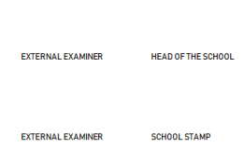

Acknowledgement

It gives me great pleasure and deep satisfaction in presenting the project towards the fulfillment of practical knowledge in python. I take the opportunity to express my sincere gratitude to several people with whose help and encouragement, I have completed this project successfully.

I would like to thank ***Ms Khushbu Ma'am*** for their able guidance, valuable suggestions and continuous encouragement during the time of project. Their supervision was very helpful to bring this work to conclusion.

Introduction

This project is made primarily for helping teachers in taking attendance. It helps them to

•Manage Student Records

•Manage Attendance Records

These are the options available to teachers:

1. Taking Attendance
2. Bring the Report for the month
3. Bring the report for a particular student
4. To check the attendance percentage of a student
5. To check the 75% percent criteria at the end of the year
6. Basic Tasks like add or delete a student
7. Update details about a student:

a)Name of the student can be updated

b)Attendance for a day of the student can also be updated

1. Display Details

a)You can display the student's table

b)The attendance table can also be displayed

c)Attendance for a particular date

d)Absentees of a particular date

This program is password encrypted.

Modules Used:

PrettyTable (For the representation of data in form of tables)

mysql.connector(For Mysql connection)

Flowchart:

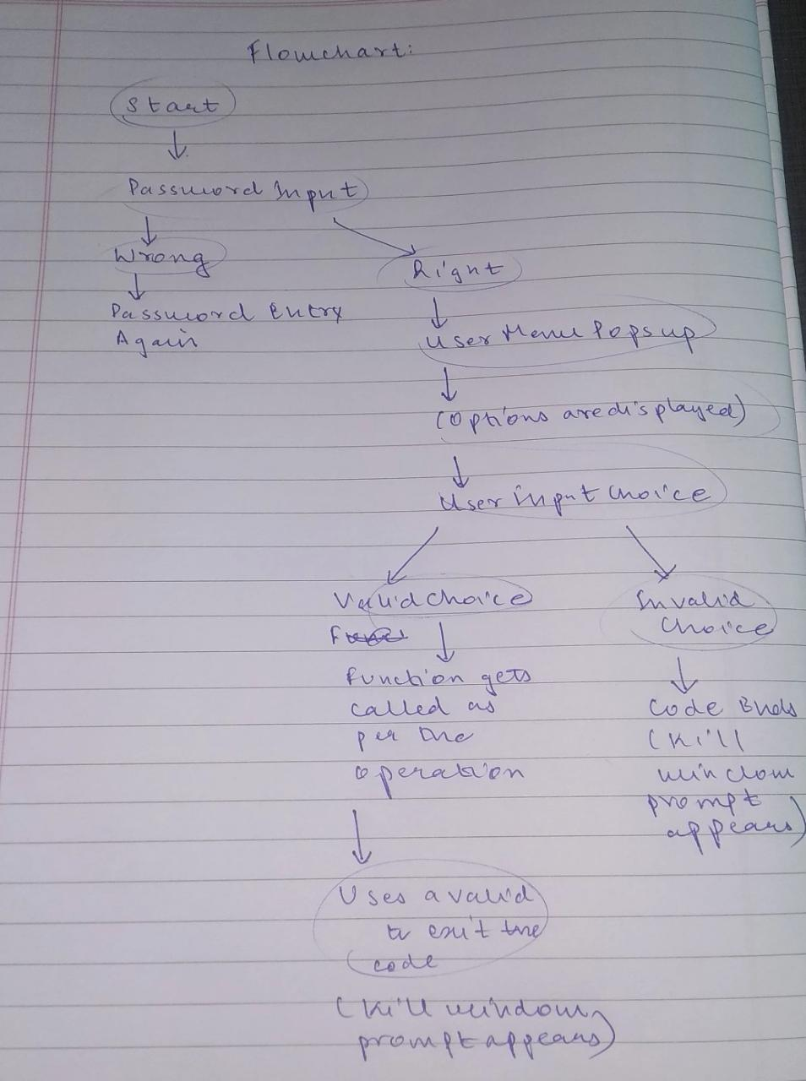

Files Generated :

Table Creation commands in Mysql

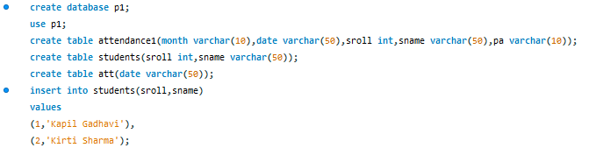

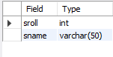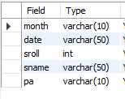

C:\Users\DELL\Desktop\cs_proj\att.PNG

3 tables have been created:  
Students: For maintaining and updating the student records.

Attendance : For taking attendance and maintaining attendance records.

Att: For keeping the account of the days attendance has been taken .

Code for establishing connection

Below is the code for displaying the menu

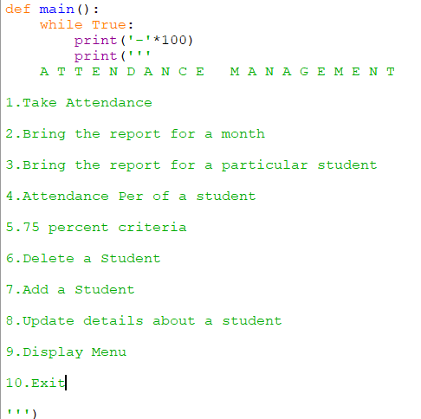

Below is the code for user choice : (continued from the def main() function)

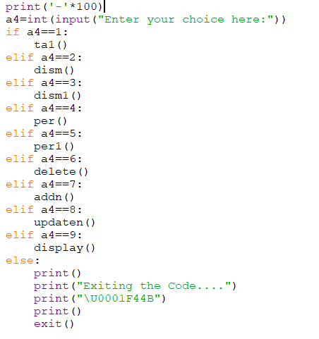

Below is the code for Password encryption. pswd() is the first function that gets called in the code.

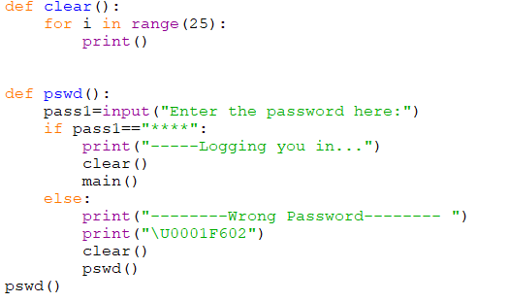

Below is the code for taking the attendance

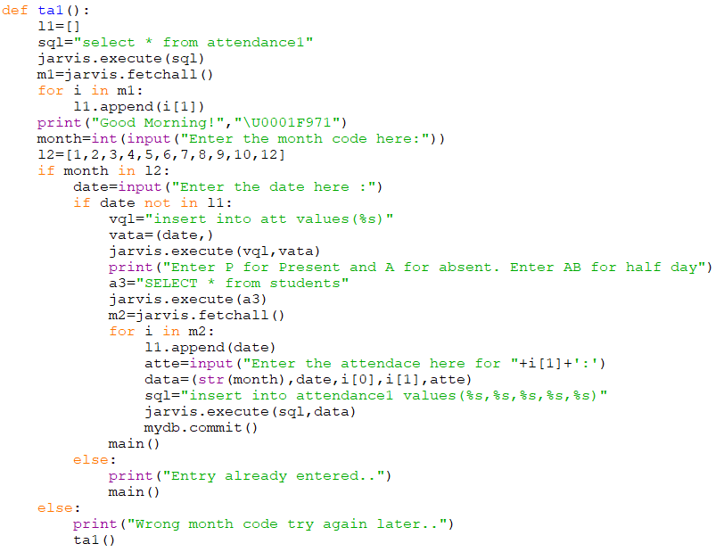

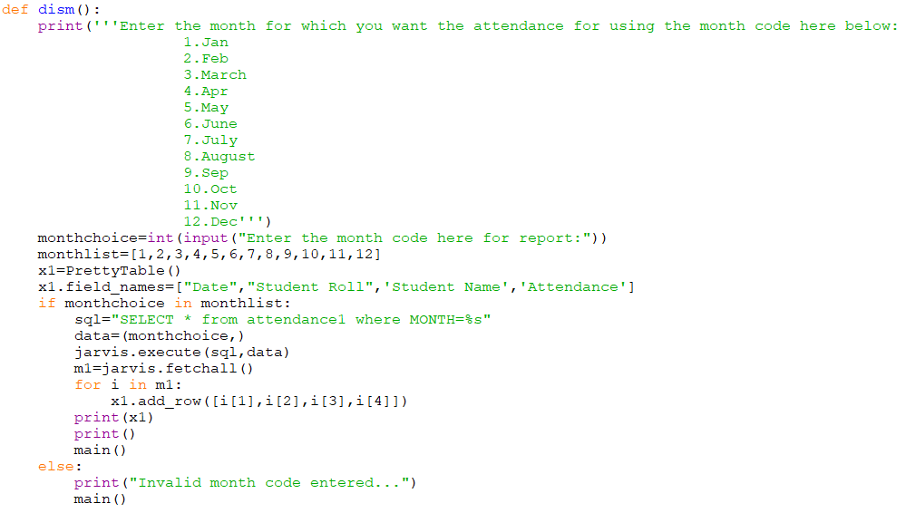Below is the code for bringing report of a month

Below is the code for bringing the report of a particular student

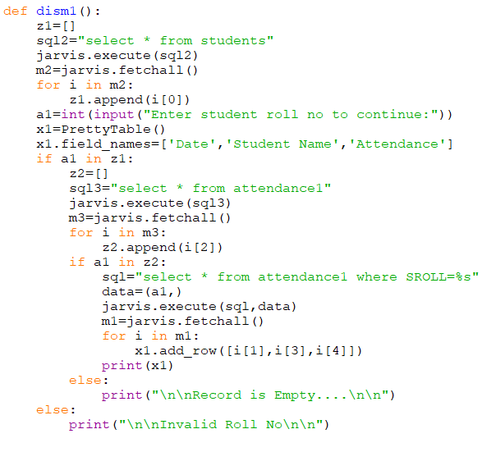

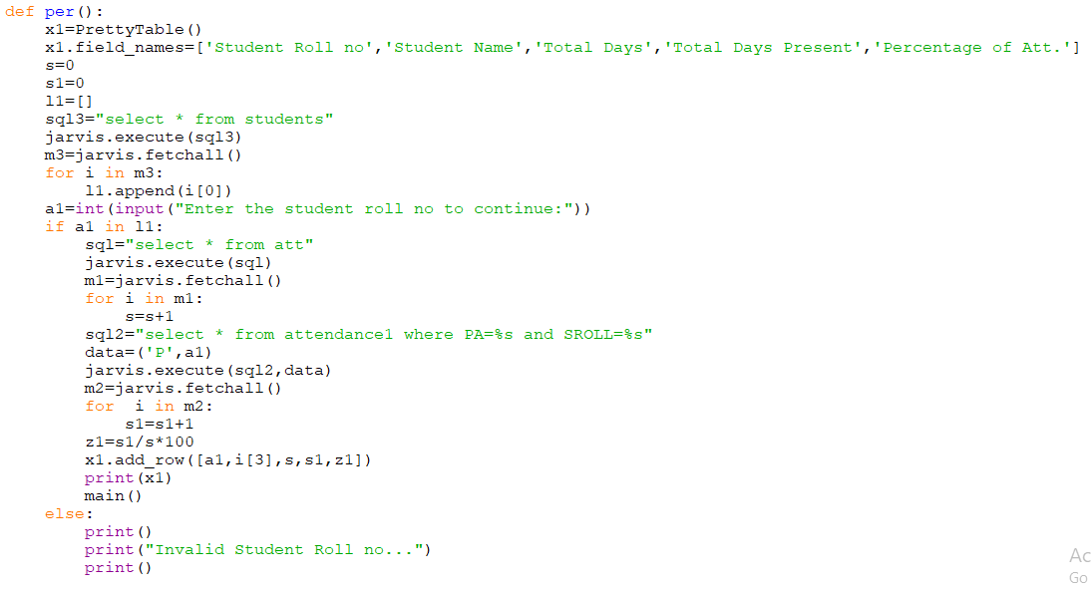Below is the code for checking the attendance percentage of a student

Below is the code for checking the 75 percent criteria of attendance at the end of the year

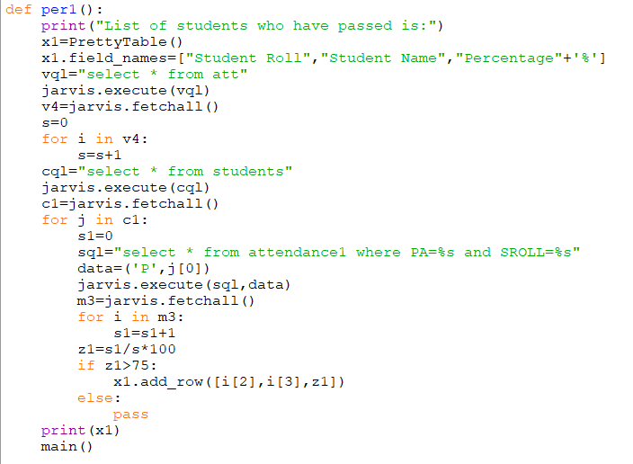

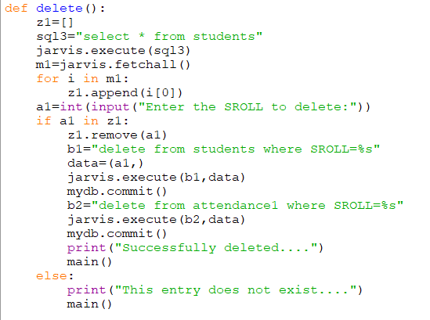Below is the code for deleting a student

Below is the code for adding a student

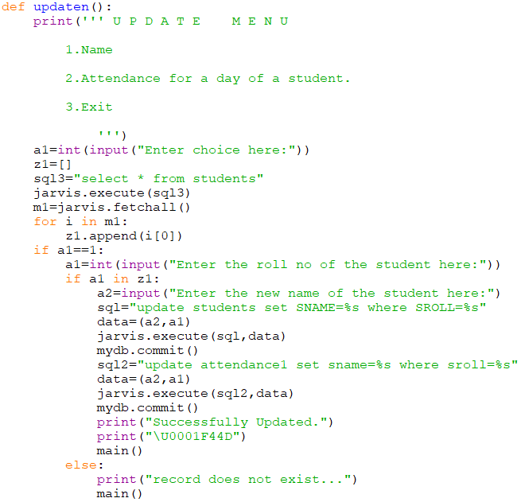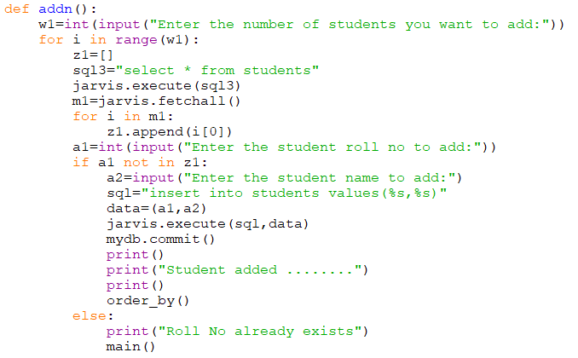Below is the code for updating details

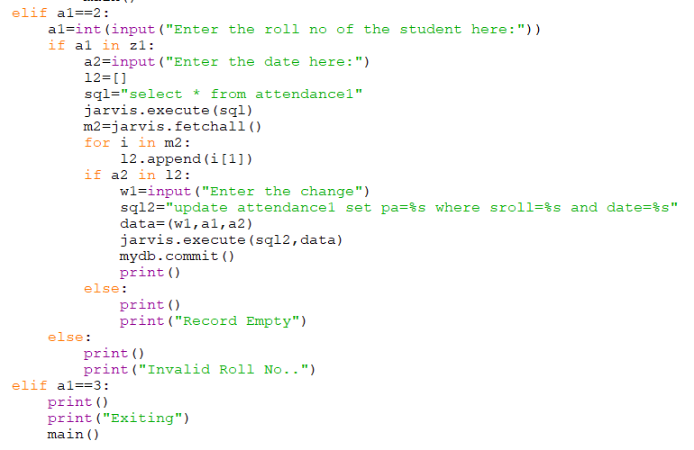

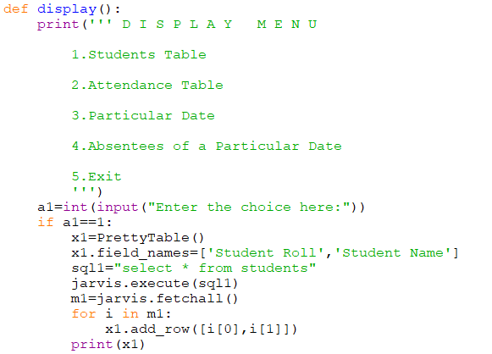Below is the code for display menu

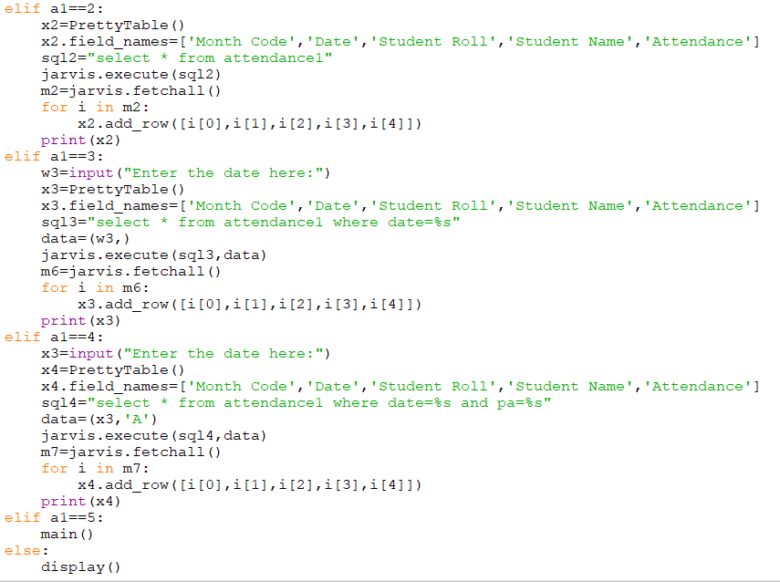

**Output Window:**

**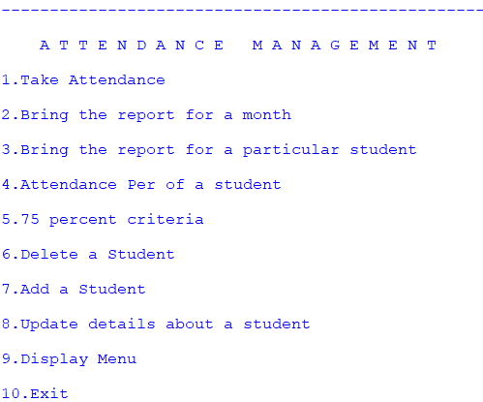**

**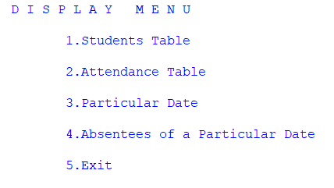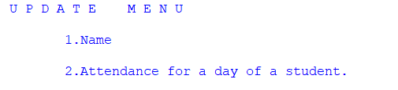**

For taking attendance:

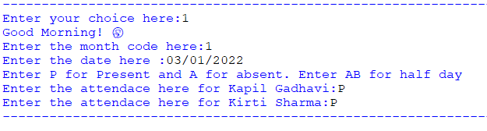

For bringing report for a month (Displayed before performing the update operations)

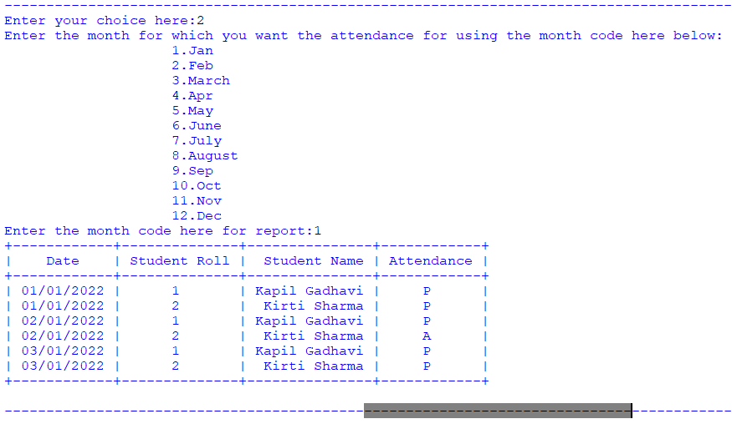

For bringing report of a particular student

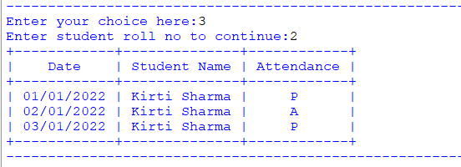

For seeing the attendance % of a student

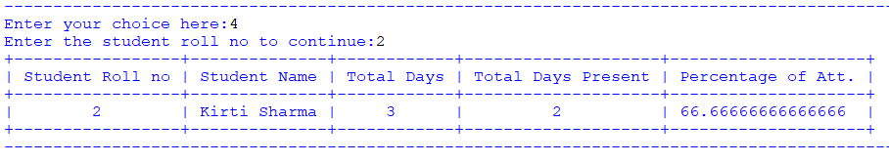

For checking the 75 per criteria (Output displayed before the Update operations were performed)

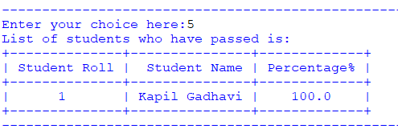

For the update menu

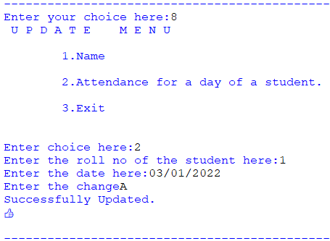

Entries displayed via the Display Menu

Before:  
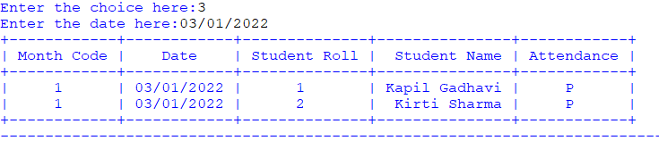

After:

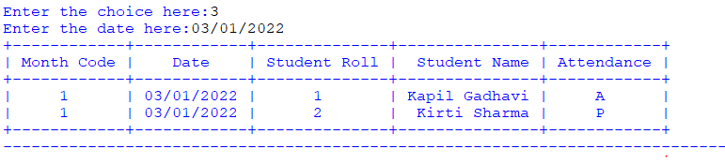

For name:

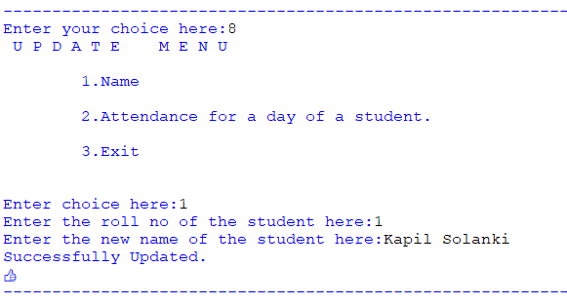

Entries displayed via the Display Menu

Before:

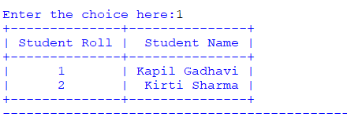

After:  
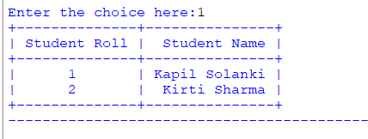

Display Menu:  
Students Table

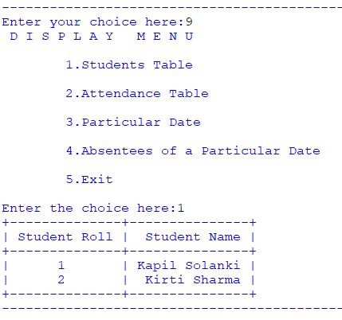

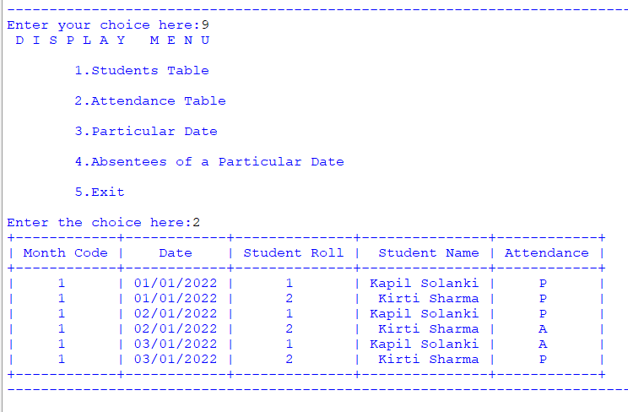Attendance Table

For particular Date

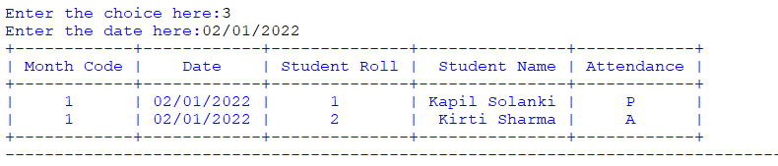

For absentees of a particular day

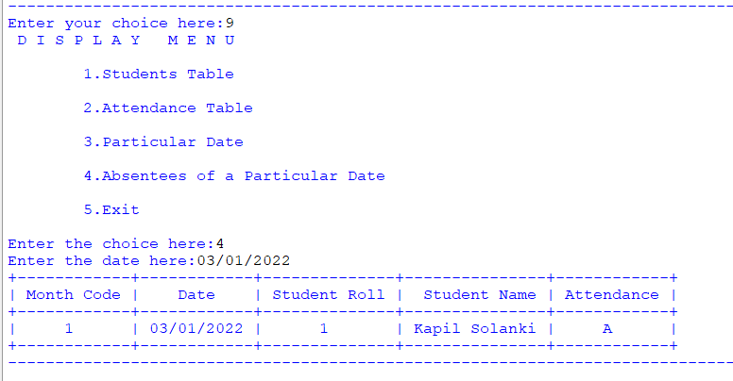

Adding a Student

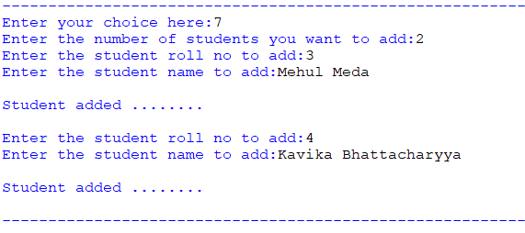

Before:  


After:  
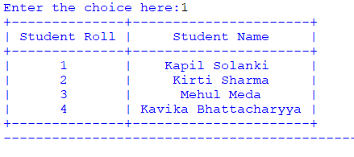

Delete a Student

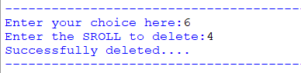

Before:  


After:  
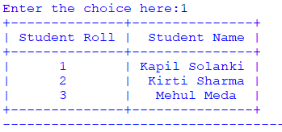

Exiting the Code:

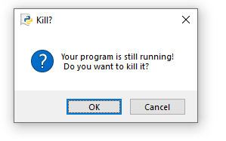

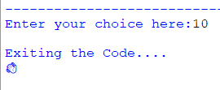

Future Scope

* An app can be made further keeping this as the base.
* Features can be changed as per the user needs
* The code can be developed and further modifies to be used by an entire school or different branches of the same school.

Bibliography:  
<https://stackoverflow.com/>

<https://www.geeksforgeeks.org/>

<https://google.com/>